**4A+1 System Design**

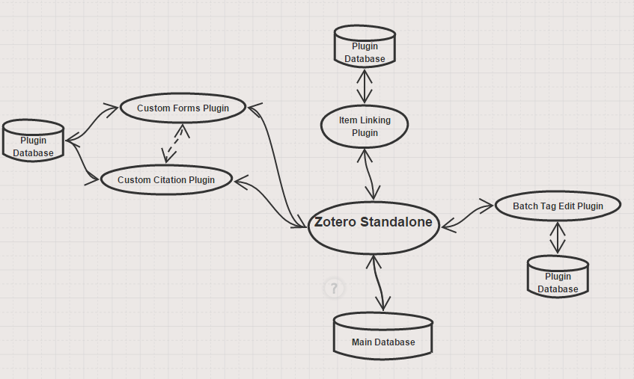

**Diagram Components:**

* **Custom Forms & Citation Plugins –** These two plugins will be created separately (at different times) but ultimately be merged to form one large plugin in the end, as the creation of custom forms requires custom citations to function properly. The custom citation plugin allows the user to arrange citations through a text-box or drag-and-drop interface. New citation types can be saved. Custom forms allow the user to manually create their own form types, which can also be saved into the database.
* **Item Linking Plugin –** This plugin will allow the user to link two Zotero items together, such that editing one will also edit the other. This functionality will also work across different libraries.
* **Batch Tag Edit Plugin –** This plugin allows the searching and editing of multiple tags at once, by allowing the selection of multiple tags at the same time (which will allow mass editing). It will use the already implemented search function.